# Experiment : Piston Propulsion

Aim: To measure the thrust produced by a piston engine for different throttle values.

# Introduction

The electric motors are simple to control and clean to work with, but the batteries that power them suffer from very low energy density. Batteries also need a lot of time to charge and have a limited number of charging cycles. Although motors are generally called green propulsion as they do not have toxic emissions, this really depends on the source from which the electricity is being produced (thermal power plant, hydel, nuclear, wind etc.). A typical flight duration for the motor battery arrangement is around 12-15 minutes.

When one needs to fly longer, a piston engine is a better choice of propulsion. Piston engines have better power to weight ratios. The chemical fuel used has high energy density. Piston engines are classified into two strokes and four strokes depending on the number of power strokes per rotation of the crank. Spark ignition, Compression ignition and glow plug ignition depending on how the charge is ignited.

Two-stroke spark-ignition engines are preferably used in unmanned aerial vehicles. Gasoline is used as fuel in these engines. The fuel flow rates are controlled using a throttle valve.

# Apparatus:

# 

**Engine:** An “UMS” spark ignition engine is used. It has a displacement volume of 34.5 cc. Max speed of 5900 rpm. Rated power of 3 kW.

**Servo:** Servos are motors used to get accurate angular position control**.** The Signal to the Servo is a Pulse width modulation (PWM) output. The throttle is connected to the servo using a control rod.

# Experimental Setup and Procedure

1. Mount the engine on the slider arrangement.
2. Place the appropriate propeller on the engine shaft and fasten the locking adaptor firmly.
3. Connect the throttle to the servo.
4. Connect the signal wire of Servo to Pin 2 of Arduino.
5. Power the servo from the battery and ground of Arduino.
6. Power the ignition box through a battery for spark generation.
7. Upload the basic LabView programme to Arduino.
8. Open the Control programme using NI LabView.
9. Run the GUI.
10. Increase the Pulse width in steps to open the throttle.
11. Let the engine run at that position till it gets steady values.
12. For each throttle position take down the measurements
    1. Note down the speed from the display.
    2. Note down the thrust from LabView.
    3. Note down the fuel tank weight before and after the test.
13. Reduce the speed and bring the engine to a halt.
14. Click on stop measurement in LabView and disconnect the ignition battery.

# Observations

| **Throttle Pos** | **Speed** | **Thrust** | **Fuel weight - Before test** | **Fuel weight - After test** | **Run time** | **Fuel flow rate** | **TSFC** |
| --- | --- | --- | --- | --- | --- | --- | --- |
| *Deg* | *RPM* | *kgf* | *g* | *g* | *s* | *g/s* | *mg/ N-s* |
| 15 | 4.4 | 4700 | 293.04 | 281.529 | 64 | 0.17985938 | 0.00390211 |
| 30 | 5.8 | 5450 | 281.529 | 276.004 | 21 | 0.26309524 | 0.00492244 |
| 45 | 6.1 | 5600 | 276.004 | 268.122 | 29 | 0.2717931 | 0.00494896 |
| 60 | 6.3 | 5690 | 268.122 | 261.408 | 23 | 0.29191304 | 0.00523124 |
| 75 | 6.35 | 5700 | 261.408 | 252.059 | 33 | 0.28330303 | 0.00506804 |
| 90 | 6.6 | 5800 | 252.059 | 244.715 | 32 | 0.2295 | 0.00403477 |

**Result and Discussion**

To understand Piston Engine Propulsion, we plot the following plots to gain insights

* **Thrust Vs Speed**

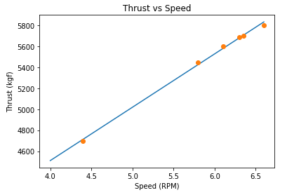

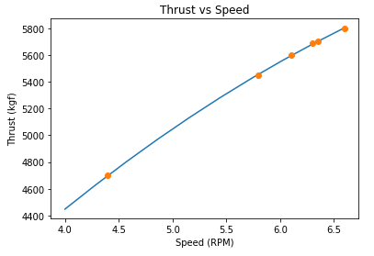

* **Thrust vs Throttle**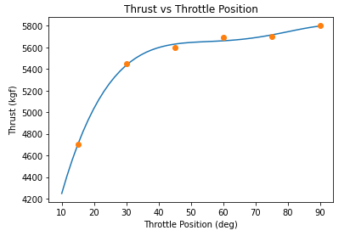
* **TSFC vs Throttle**

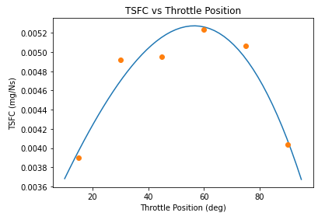

**Conclusion:**

* The Thrust generated increases with the increase in speed. This increase is nearly linearly proportional to the increase in speed.

* The Thrust generated increases rapidly as the Throttle position increases from 0**°**.

The rate of increase of Thrust with increase in Throttle position reduces as the the Throttle position increases and is very less as Throttle position nears 90**°**

The Thrust generated is maximum at 90**°** Throttle Position.

* The TSFC increases until a certain critical Throttle Position and then decreases again as the Throttle position in increased beyond this critical point

* Thus, we can see that beyond the Critical Throttle position, we have high value of Thrust along with a reducing TSFC as we increase the Throttle angle, with optimal Thrust being generate at throttle angle = 90**°**.